Write a database trigger on Library table. The System should keep track of the records that are being updated or deleted. The old value of updated or deleted records should be added in Library_Audit table.

**PL/SQL Block: -**

CREATE TABLE lib_tab(book_name VARCHAR2(25),status VARCHAR2(15));

CREATE TABLE library_audit(date_modified DATE, book_name VARCHAR2(25),old_status VARCHAR(15),new_status VARCHAR2(15),action VARCHAR2(25));

INSERT INTO lib_tab VALUES('TOC','AVAILABLE');

INSERT INTO lib_tab VALUES('DSA','UNAVAILABLE');

INSERT INTO lib_tab VALUES('CNS','AVAILABLE');

INSERT INTO lib_tab VALUES('SPOS','UNAVAILABLE');

INSERT INTO lib_tab VALUES('IOT_ES','AVAILABLE');

CREATE OR REPLACE TRIGGER trigger_1

AFTER UPDATE OR DELETE OR INSERT ON lib_tab FOR EACH ROW

ENABLE

BEGIN

IF UPDATING THEN

dbms_output.put_line(:OLD.status);

INSERT INTO library_audit VALUES (SYSDATE,:OLD.book_name,:OLD.status,:NEW.status,'UPDATE');

ELSIF INSERTING THEN

dbms_output.put_line(:NEW.status);

INSERT INTO library_audit VALUES (SYSDATE,:NEW.book_name,:OLD.status,:NEW.status,'INSERT');

ELSE

dbms_output.put_line(:OLD.book_name||'deleting');

INSERT INTO library_audit VALUES(SYSDATE,:OLD.book_name,:OLD.status,:NEW.status,'DELETE');

END IF;

END;

/

SELECT * FROM lib_tab;

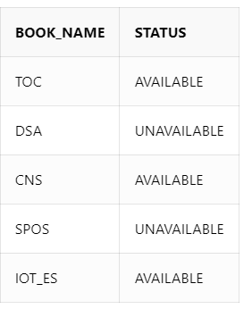

DELETE FROM lib_tab WHERE book_name = 'CNS';

UPDATE lib_tab SET status = 'UNAVAILABLE' WHERE book_name = 'TOC';

UPDATE lib_tab SET status = 'PRE-ORDER' WHERE book_name = 'SPOS';

UPDATE lib_tab SET status = 'AVAILABLE' WHERE book_name = 'IOT_ES';

INSERT INTO lib_tab VALUES('DBMS','AVAILABLE');

SELECT * FROM library_audit;

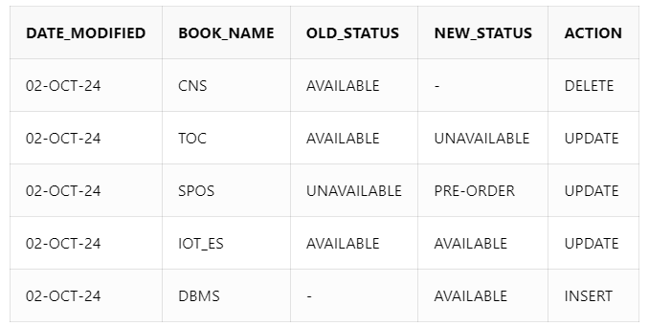

SELECT * FROM lib_tab;

